|  |
| --- |
| Nk gAmes |
| Planet Defence |
|  |
| Version #1.0  All work Copyright © 2013 by NK Games.  All rights reserved. |
| **Nolan Knill** |
|  |

|  |
| --- |
| January 24th, 2013 |

**Table of Contents**

Version History 3

Detailed Game Description 4

Controls 4

Interface Sketch 4

Screen Descriptions 5-9

Game World 9

Levels 9

Characters/Vehicles 10

Enemies 10

Weapons 10

Scoring 10

Sound Index 10

Art/Multimedia Index 10

**Version History**

**Version History can be verified through GitHub:** <https://github.com/riprap/project/commits/master>

**January 13, 2013**

* Avatar movement added
* Added mouse click recognition, so bullets can be fired in mouse direction

**January 15, 2013**

* Add scoreboard overlay.
* Bullet class complete, startScreen class begun

**January 18, 2013**

* Continue with enemy class, added enemyGroup to have multiple enemies
* Added Planet class and removed previous character sprite(size)

**January 22, 2013**

* Change bullet.gif, stop ship from leaving screen, added movement to enemies, added resets for when enemies hit planet, bullet, or ship
* Add multiple enemies, changed planet size

**January 23, 2013**

* Add explosions

**January 24, 2013**

* Added sounds and started difficulty.
* HealthPackage class added, documentation complete, instructions (start and end screens) polished. Game over and explosion sounds added, as well as health package images

1. **Game Overview**

*Planet defence is a space arcade planet defence game. The player takes control of a spaceship, and must defend his planet from incoming, self-destructing Electrodes, by shooting them with lasers from his ship.*

1. **Detailed Game Description**

The user has to defend a planet that has 5 points of health. Each time an Electrode hits the planet, the planet loses a point of health. If the spaceship crashes into the planet, or an Electrode, the spaceship explodes, and so will the planet. Health packages come in every so often based on the difficulty level. Capturing the health packages in your ship adds a point of health to your planet.

1. **Controls**

*Arrow Keys or WASD – Movement*

*Left mouse – Shoot Laser*

*Mouse pointer – Aim laser*

1. **Interface Sketch**

Score Health top left. Red circles represent Electrodes. Spaceship represented by small blue circle. Defence planet represented by blue circle.

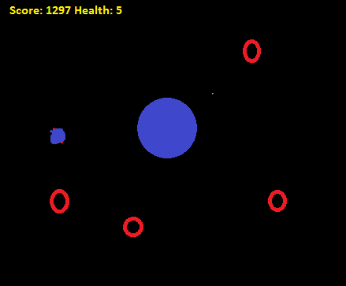

1. **Screen Descriptions**

Start Screen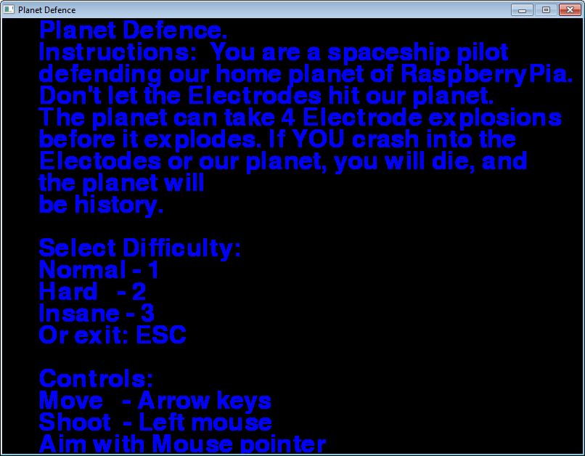

Normal Difficulty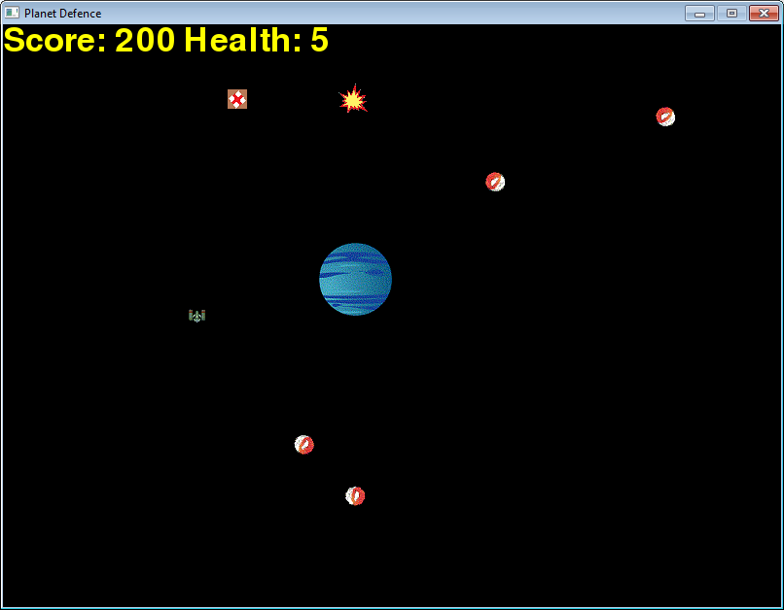

Hard Difficulty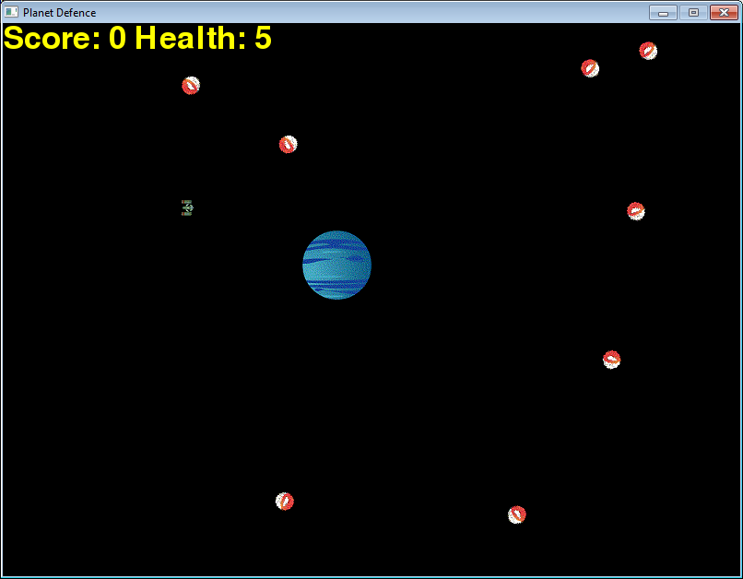Insane Difficulty 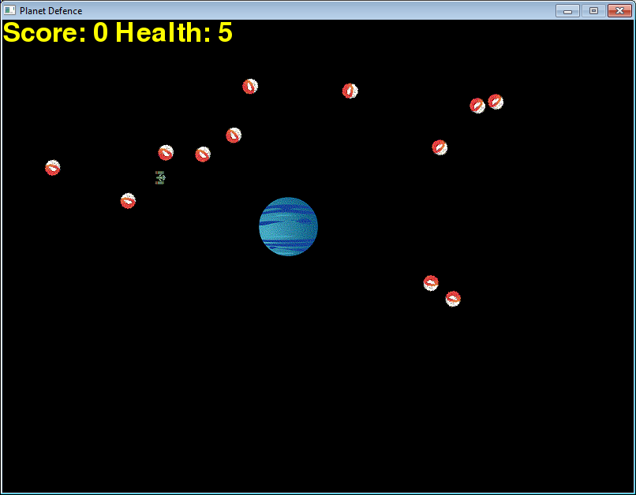

Game End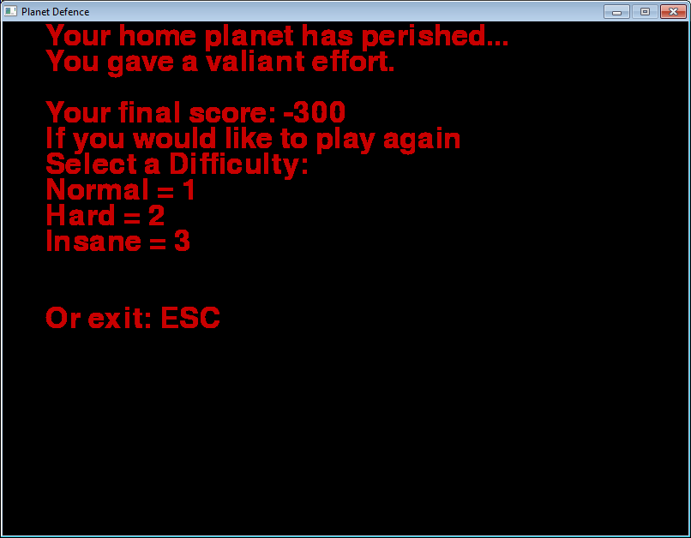

1. **Game World**

*The game world is the surrounding space around our home planet RaspberryPia. You will control our warship to try and take down incoming Electrodes from destroying our planet.*

1. **Levels**

*Normal: User has to face a minimal amount of enemies*

*Hard: User has to contend with more enemies and less health packages.*

*Insane: User must be an expert to play this mode. Enemies come in harder and faster than they’ve ever seen before, and with almost no health packages to help them try to survive.*

1. **Characters/Vehicles**

*The user takes control of RaspberryPia’s greatest space warship.*

1. **Enemies**

*The enemies that you will be facing come from the planet of Kanto, and are formerly known as Electrodes. They self-destruct on contact, so be weary of where you are at all times, and don’t let them touch our planet!*

1. **Weapons**

*You will have access to the Laser aboard our warship to shoot enemies.*

1. **Scoring**

*Kill an electrode – 200 points*

*Find a health pack – 50 points*

*Allow an electrode to get to RaspberryPia - -100 points*

*Hit RaspberryPia with laser - -100 points*

1. **Sound Index**

*Home screen Soundtrack –* ***Power by Kanye West***

*Gameplay Soundtrack -* ***background.ogg*** *space noises*

*Explosion –* ***explosion.ogg*** *and* ***shortExplosion.ogg*** *for explosions*

*Laser shots –* ***pew.ogg*** *Laser noises*

*Game over voiceover –* ***gameOver.ogg***

1. **Art/Multimedia index**

*    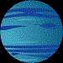 *

*bullet.gif electrode.gif explosion.png health.png planet.gif ship.bmp*